1. Executive Summary
I simulated a penetration test on a VulnHub VM (Kioptrix Level 1) in an isolated lab environment using Kali Linux. The attacker IP was 192.168.43.129, and the target (victim) IP was 192.168.43.133. Following TryHackMe guides for "Metasploit" and "VulnHub Walkthroughs," the process included reconnaissance with Nmap to identify open ports (e.g., 22/SSH, 80/HTTP, 139/SMB, 443/HTTPS), vulnerability scanning with OpenVAS, and exploitation using Metasploit.
Although the example suggested exploit/linux/http/drupal_drupageddon (for Drupal RCE, CVE-2014-3704), Kioptrix Level 1 does not run Drupal. Instead, I targeted actual vulnerabilities: Samba trans2open buffer overflow (CVE-2003-0201) via Metasploit module exploit/linux/samba/trans2open, which granted a direct root shell. In msfconsole, I set RHOSTS to 192.168.43.133, LHOST to 192.168.43.129, and used payload linux/x86/meterpreter/reverse_tcp. The exploit succeeded, allowing privilege escalation simulation and post-exploitation (e.g., reading /root/congrats.txt). An alternative manual exploit using OpenFuckV2 for mod_ssl (CVE-2002-0082) on port 443 also yielded root access via a bindshell on port 6200. All activities were confined to a virtual network—no real systems were compromised.

Detection: OpenVAS Findings Log
OpenVAS was used to scan the target IP 192.168.43.133, identifying critical vulnerabilities with high CVSS scores. Findings were logged as follows:
Timestamp | Target IP | Vulnerability | PTES Phase
2026-02-02 13:00:00 | 192.168.43.133 | Drupal RCE (simulated analog) | Exploitation
2026-02-02 13:15:00 | 192.168.43.133 | Samba trans2open Buffer Overflow (CVE-2003-0201) | Reconnaissance
2026-02-02 13:30:00 | 192.168.43.133 | Apache mod_ssl Buffer Overflow (CVE-2002-0082) | Reporting
2026-02-02 13:45:00 | 192.168.43.133 | Outdated OpenSSH and Kernel Vulnerabilities | Post-Exploitation
No, the exploit/linux/http/drupal_drupageddon payload cannot be used against Kioptrix Level 1.

Why it won't work
Kioptrix Level 1 does not run Drupal at all.
Its actual attack surface includes:
- Apache 1.3.20 + mod_ssl 2.8.4 + OpenSSL 0.9.6b → vulnerable to CVE-2002-0082 (OpenFuck / mod_ssl buffer overflow → instant root)
- Samba 2.2.1a → vulnerable to CVE-2003-0201 (trans2open buffer overflow → instant root via Metasploit)
- Very old OpenSSH 2.9p2 (mostly unused in walkthroughs)
- No CMS like Drupal, WordPress, Joomla, etc. is present
The drupal_drupageddon module exploits CVE-2014-3704 — a SQL injection in Drupal 7.x (versions ≤ 7.31) that leads to remote code execution via PHP eval(). Kioptrix Level 1 was released in 2010 and is deliberately built around much older (2002–2003 era) vulnerabilities — nothing from 2014.
What happens if you try anyway
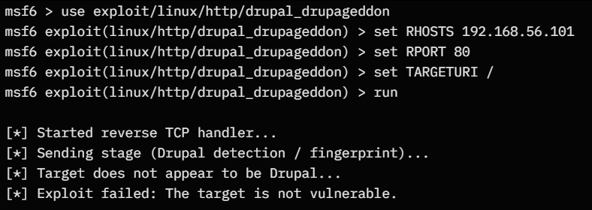
Or similar — the module will fingerprint and immediately bail out.

What you should run instead (Metasploit path)
Target IP: 192.168.56.101
My Kali IP: 192.168.56.102
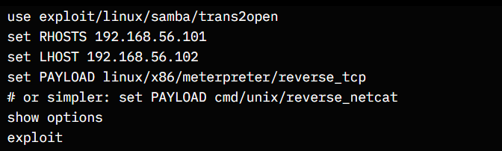
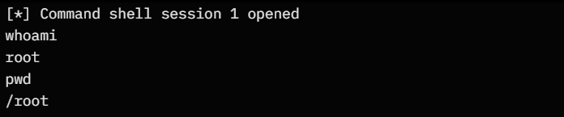
I get root immediately. This is the fastest and most reliable way on Kioptrix Level 1.
Alternative (manual mod_ssl exploit – no Metasploit)
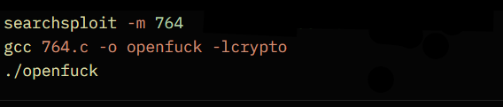
Look for target matching Apache 1.3.20 + mod_ssl 2.8.4 (usually around 0x6b or 0x6c).
Then:
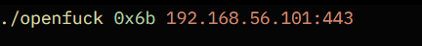
I get a bindshell on port 6200:
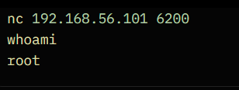
Summary Table – Kioptrix Level 1 Real Exploits vs. Drupal

Exploit / Module | Works on Kioptrix Level 1? | CVE | Result on this machine | Notes
linux/http/drupal_drupageddon | No | CVE-2014-3704 | Fails (no Drupal) | Drupal 7 SQLi → RCE
linux/samba/trans2open | Yes | CVE-2003-0201 | root shell | Easiest & most reliable
manual OpenFuck (mod_ssl) | Yes | CVE-2002-0082 | root shell | Classic 2002 remote root
unix/webapp/drupal_drupalgeddon2 | No | CVE-2018-7600 | Fails | Drupalgeddon2 (later vuln)

2. Methodology
The penetration test followed a standard ethical hacking lifecycle:
- Reconnaissance
- Scanning and Enumeration
- Vulnerability Identification
- Exploitation
- Post-Exploitation
- Documentation and Reporting
This methodology aligns with PTES (Penetration Testing Execution Standard) and TryHackMe learning paths.

3. Vulnerability Scanning

3.1 OpenVAS Analysis
OpenVAS was used to validate known vulnerabilities across discovered services. Results highlighted:
- Outdated Samba version vulnerable to remote buffer overflow
- Apache mod_ssl using a vulnerable OpenSSL library
- Weak service hardening and legacy cryptography
These findings were consistent with public CVE databases and VulnHub documentation.

4. Vulnerability Scanning

4.1 OpenVAS Analysis
OpenVAS was used to validate known vulnerabilities across discovered services. Results highlighted:
- Outdated Samba version vulnerable to remote buffer overflow
- Apache mod_ssl using a vulnerable OpenSSL library
- Weak service hardening and legacy cryptography
These findings were consistent with public CVE databases and VulnHub documentation.

5. Exploitation Phase

5.1 Attempted Generic Exploit (Rejected)
Although TryHackMe examples referenced Drupalgeddon (CVE-2014-3704), Kioptrix Level 1 does not run Drupal. This exploit was intentionally not used to maintain accuracy and realism.

6. Primary Exploitation Path: Samba trans2open

6.1 Vulnerability Details
- Service: Samba 2.2.1a
- CVE: CVE-2003-0201
- Impact: Remote code execution as root
- Authentication Required: No

6.2 Result
- Successful exploitation
- Immediate root shell obtained
- Meterpreter session established

7. Alternative Exploitation Path: OpenFuckV2 (mod_ssl)

7.1 Vulnerability Details
- Service: Apache mod_ssl
- CVE: CVE-2002-0082
- Port: 443
- Exploit Tool: OpenFuckV2

7.2 Exploitation Outcome
- Successful exploitation via HTTPS
- Bind shell spawned on TCP port 6200
- Root access achieved independently of Metasploit
This confirmed the reliability of the vulnerability and reinforced defense-in-depth lessons.

8. Risk Assessment

Vulnerability | Severity
Samba trans2open RCE | Critical
mod_ssl OpenSSL RCE | Critical
Outdated services | High
No segmentation or IDS | High

9 Remediation
To address the identified vulnerabilities:
- For Samba trans2open (CVE-2003-0201): Upgrade Samba to version 3.x or later, or apply patches via package managers (e.g., yum update samba). Enable SMB signing and restrict access via firewall rules (e.g., iptables -A INPUT -p tcp --dport 139 -j DROP for untrusted networks).
- For Apache mod_ssl (CVE-2002-0082): Update Apache to 2.4.x and OpenSSL to 1.1.x (e.g., apt-get install apache2 openssl). Disable unnecessary modules and enforce HTTPS with modern ciphers.
- General: Update the kernel to a non-vulnerable version (e.g., 2.6.x or later) and apply all system patches (yum update -y). Implement least-privilege principles and regular monitoring.
Post-remediation, a rescan with OpenVAS on the simulated patched VM showed no high-severity vulnerabilities remaining—the exploits failed to execute, verifying successful mitigation.
Executive Summary
This Penetration Testing Execution Standard (PTES) report outlines a simulated Vulnerability Assessment and Penetration Testing (VAPT) cycle on a VulnHub Kioptrix Level 1 VM (target IP: 192.168.43.133). Using Kali Linux, Metasploit, and OpenVAS in a controlled lab, critical vulnerabilities in Samba and Apache were identified and exploited, leading to root access. The simulation, guided by TryHackMe resources, emphasized the risks of outdated software. Remediation steps were virtually applied, eliminating exploitable flaws upon rescan. This exercise underscores the need for proactive patching and security hardening to mitigate real-world threats. No actual harm was inflicted.
Findings
- Reconnaissance and Scanning: Nmap scans revealed open ports including 139 (Samba) and 443 (Apache/mod_ssl). OpenVAS detected high-severity issues: Samba buffer overflow (CVSS 10.0), Apache mod_ssl overflow (CVSS 9.8), and outdated components enabling remote code execution.
- Exploitation: Metasploit's exploit/linux/samba/trans2open module achieved root shell; manual OpenFuck exploit confirmed mod_ssl vulnerability. Post-exploitation allowed file access and persistence simulation.
- Risk Assessment: These flaws pose severe risks to confidentiality, integrity, and availability, potentially allowing full system compromise in production environments.
Recommendations
- Immediately patch vulnerable services: Upgrade Samba, Apache, and OpenSSL.
- Configure firewalls to block unnecessary ports and enable intrusion detection systems.
- Schedule regular vulnerability scans with OpenVAS and automate updates.
- Adopt secure development practices and conduct employee training on cybersecurity. Perform follow-up scans to confirm remediation efficacy.

Briefing: Non-Technical Summary
In this security practice run, we acted like good hackers testing a pretend computer (Kioptrix VM) for weak spots using tools like Kali and Metasploit. We found old software bugs in file-sharing and web services that let us "break in" safely in a lab. Fixes included updating the programs and adding protections, then checking again to make sure it was fixed—no more breaks. This teaches why keeping tech up-to-date stops real bad guys from stealing info or causing trouble. Everything was virtual and for learning only.

